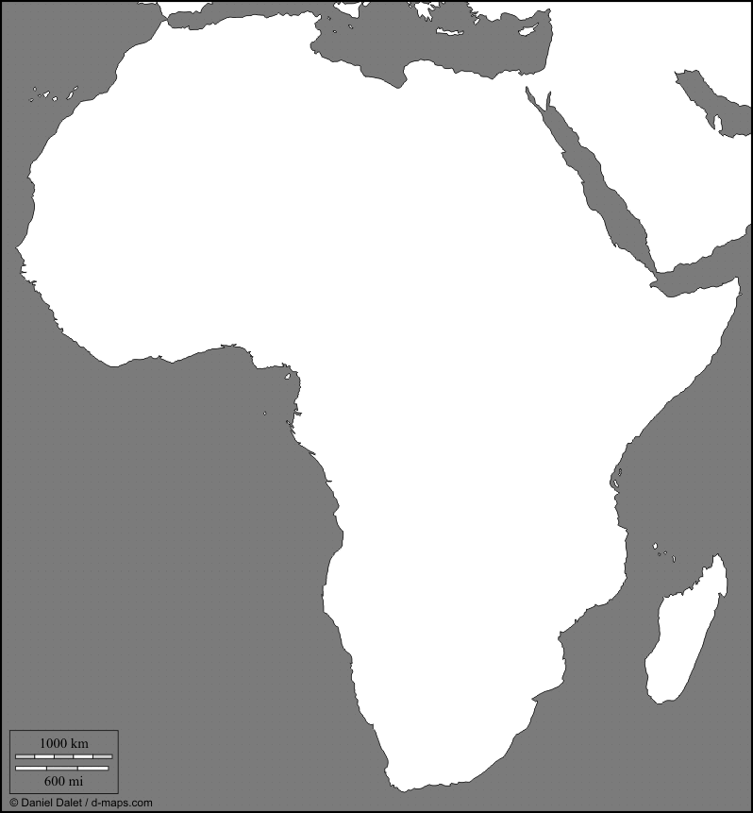

Africa Map
Use the maps on pages 222, 407, and 423 in your textbooks to help you color and label the following items:
- Empires- Ghana, Mali, and Songhai
- Cities- Timbuktu, Mogadishu, Mombasa, and Kilwa
- Rivers- Nile, Congo, and Niger
- Also label- the land routes of the Bantu Migration, and the sea routes of Trade from the Middle East

