CP World History (Unit 6, #2) Name ______________________________
Date ___________________ Pd ________

The Rise of the Renaissance

I. The Renaissance
A. Western Europe emerged from the ________________________ during an era known as the Renaissance:
1. From 1300 to 1600, Western Europe experienced a “____________” in trade, ___________, & Greco-Roman ideas
2. During the Renaissance, Europeans developed new ideas in _____________, gov’t, & human _________________
3. The Renaissance marked the beginning of the “__________________________________________”
II. What changed during the Middle Ages that gave rise to the Renaissance?
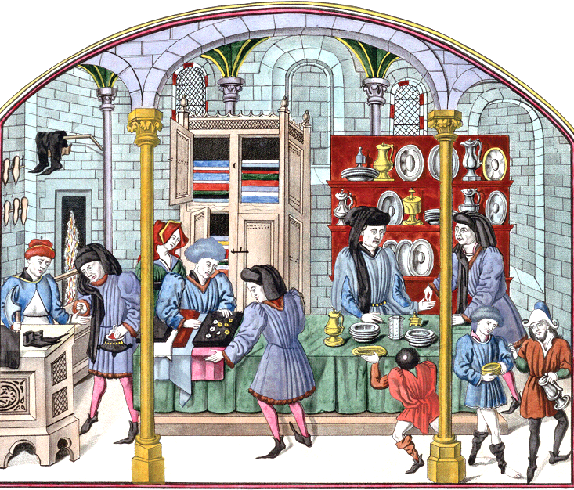
A. Trade and Cities
1. The ___________________________ increased European demand for __________________________________________ from Asia
a. Italian ________________________ began meeting the demand for ______________________ in Europe
b. As a result, Italian ___________ & a wealthy _______________ class began to form in Italy
2. The most important Italian city was ___________________, where wealth from ____________________ sparked the Renaissance
a. A new middle class of ___________________, merchants, & skilled craftsmen gained lots of ________________
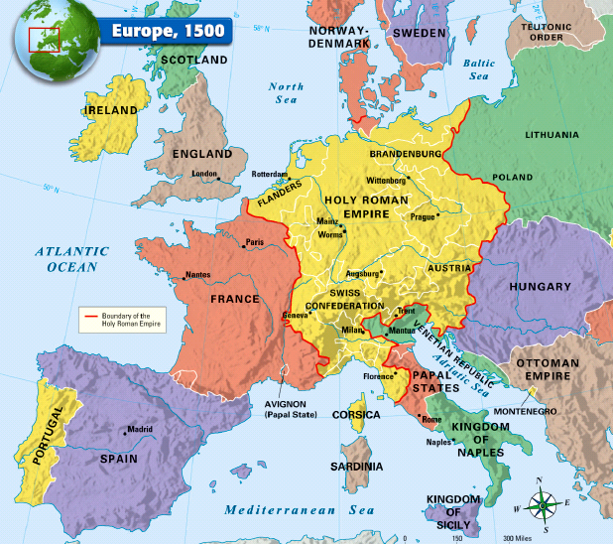
b. The _________________ family were wealthy ______________ who used their wealth to turn ___________________________ into Italy’s most ________________________ city
B. Government
1. ________________ were able to __________ merchants & use their wealth to build _______________ & strong nations which hurt the power of the _________________________________________
2. From 1337 to 1453, _______________ & _______________ began a conflict called the Hundred Years War
a. During the war, _____________________________ increased as people became loyal to their king & _________________, rather than their lord
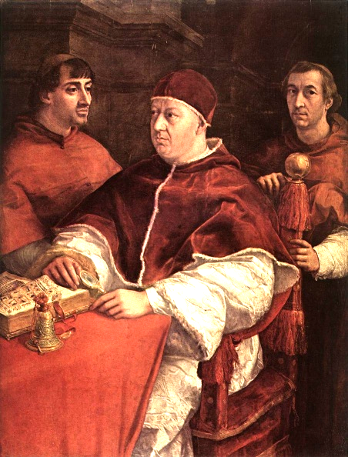
b. During the ________________________________________ War, new military ______________________________ decreased the power of feudal lords & knights
i. The discovery of Chinese ______________________ led to the development of ___________________ which helped armies penetrate castles
ii. The invention of the ___________________ allowed soldiers to shoot accurately up to _________ yards which decreased the importance of _________________ on horseback
C. Religion
1. In the late Middle Ages, the _______ & the _________________ Church lost some of its influence as a result of the losses to _______________ armies during the Crusades
2. Despite having less ___________________________, the Catholic Church was still an important part of peoples’ lives & the pope remained _________________________
D. Human Potential
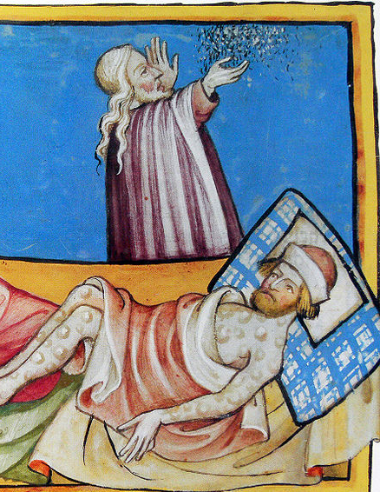
1. During the Middle Ages, peasants did not own _______________ & had no options other than remaining loyal to a ___________________________ & work within the ________________________ system
2. The rise of _______________ during the Renaissance gave people options to leave the manor & move to ________________ to serve as merchants or skilled artisans
3. One reason for the decline of the manorial system was the ___________________, known as the _________________________________________
a. In 1347, a trade ship arrived in Italy carrying plague-infested ____________
b. The plague swept ___________________ throughout Europe along trade routes
c. The plague killed _____________________________________ people in 5 years ( _____ of Europe’s population)
d. The plague caused a _________________ shortage; those that survived could demand higher ________________ & more rights
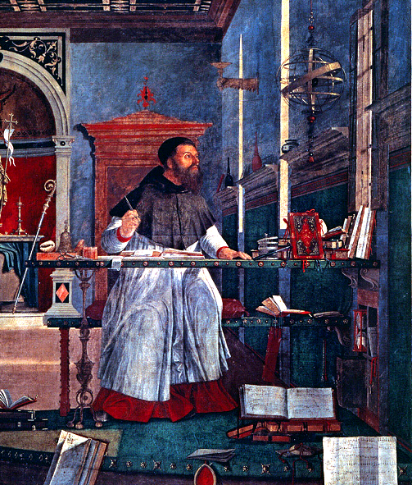
4. During the Renaissance, people had more _______________ than ever before which led to a belief that people can _________________________________
5. __________________ became the center of attention during the Renaissance
a. Social _________________ was based on wealth & __________________, not birthright
b. A new way of ___________________ began during the Renaissance called ___________________________
c. Humanists studied the “____________________” ideas of Greece & Rome & believed that __________________ could make the world a better place
6. What was expected of men & women in the Renaissance?
a. The “_________________________” was well educated, smart, can dance, write poetry, & play music; (called a “________________________ Man”)
b. The “_____________________________” should have the same qualities as men but should not seek ____________ or political ________________; (Renaissance women were better educated but had _____________________________ than medieval women)
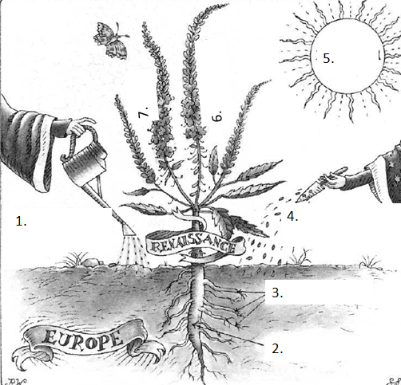
Closure Activity:
Directions: The image to the right is a visual metaphor that shows the factors that led to the Renaissance in Europe. Use the word bank to label each of the 7 parts on the visual. Be prepared to discuss your answers

Visual Metaphor Word Bank
- Classical ideas of Greece and Rome
- The growth of city-states
- Travel and trade
- Learning
- Medieval ideas
- Art
- Humanism

