Early Medieval & Romanesque Guided Notes -
Mrs. Henderson’s Class - Chapter 14
Vocabulary
Ambulatory: ___________________________
Cloister: a covered __________ surrounding ____________________
Feudalism:
Monasticism: a way of life _________________________
Pilgrimage: a journey to a holy place
Serfs: poor peasants who didn’t have land to give in return for protection
Tapestries: textile _____ hangings that were _______, ________, or _______________
Transept: another ______________________ and side aisles (makes the church look like a cross)
Tympanum: the half-round _____________ between the lintel and the arch __________________ of the church
animal style
Cloisonne: A style of jewelry e_______ is melted inside lines. It looks like st______ gl____
Codex -
Horror Vacui - The fear of a v__________ (in other words no em______ space)
Westwork
Illuminated Manuscripts - a system Illuminations: __________ paintings

Page 311
The period known as the Middle Ages was a splendid time for bookmaking, architecture, and sculpture. It is called the Age of Faith, since people were fixed on preparation for life after death, and the Church was all-powerful. The Middle Ages can be divided into three periods, the Early M________, the Ro__________, and the G______.
Page 312
The Carolingian dynasty emerged during the Early Medieval period, after a time of conflict. In the year 800 King Charlemagne was crowned by the pope and became the first Holy Roman Emperor. He established law and order and encouraged the arts.
Page 313
After his death in 814, western Europe reverted to disorder. A system known as f________ arose, in which weak noblemen gave their lands and freedom to more powerful lords in return for protection. Most people, however, were _____, poor peasants obligated to work the lands of the noblemen.
Page 314
In architecture, church builders continued to use the design of the basilica but they added tr_______, side aisles that cut across the nave, giving each church the form of a cross. Many people devoted their lives to religion, living in remote communities known as monasteries.

Page 315
These monasteries had open courts known as _________ that provided monks a place for contemplation and prayer.
Page 316
Monks worked at copying books by hand and creating brilliant ill_____________, or manuscript paintings, in the books. These illustrations, as well as carvings and reliefs, were meant to teach and inspire the people in their faith.

Lesson 2
The Romanesque Period
Page 319
After the Early Medieval period, a new artistic style known as the R___________ emerged. Seen mainly in church architecture, the Romanesque lasted until the middle of the twelfth century.
Page 320
Constant disputes over land under the f______ system caused nobles to build fortified castles. When in the thirteenth century trade and industry grew, cities were built with stone barricades around them.
Page 321
At the center of each town was a richly decorated stone church. Churches were also built at pilgrimage destinations, where people would journey to visit the sacred remains of a saint.
Page 322
Architects continued to build using a nave and a transept, often adding side aisles and an a__________y, an aisle curving around behind the main altar. Romanesque churches appear large and solid from the outside and the small windows make the interiors dark and solemn.
Page 323
Many churches used relief sculptures to teach the faith to the people. While the sculptures depict many biblical figures, fantastic half-human and half-animal creatures also lurk among the carvings. The capitals of columns are carved with quaint stories that are humorous but also have Christian meanings.
Page 330
Large paintings decorated the inside walls of churches. Artists drew on Byzantine themes and used the style of manuscript illuminations, which continued to be an important art form.
Page 331
All of Romanesque painting presents easy-to-read messages with flat, colorful shapes and bold lines.

What is this:
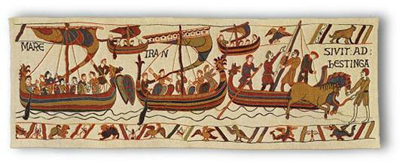
What is this:
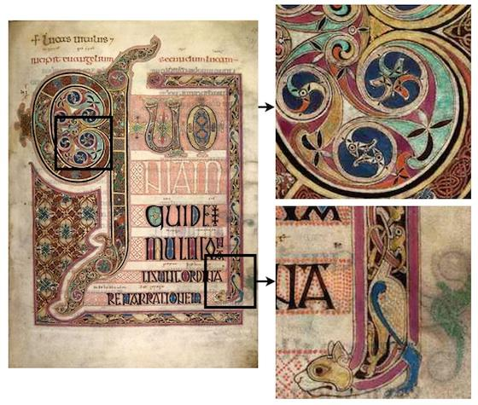
What is this:
