**Midterm Review Using the EOC book for each of the pages listed OR online using GA K-12 site**

***Part 1. Macromolecules*** *Beginning on pg. 93 in EOC or* <http://cms.gavirtualschool.org/Shared/Science/Biology17/BiologicalMolecules/index.html>

1. Catalyst:________________________________________________________________________________________________________________
2. ActivationEnergy:________________________________________________________________________________________________________
3. Enzyme:________________________________________________________________________________________________________________
4. Substrate:______________________________________________________________________________________________________________
5. Organic Molecules contains _________________________
6. Inorganic Molecules do NOT contain _______________________

**Read pages 93-98 as a group using the reading strategy we learned. (*Reciprocal Reading)**

*Fill in the chart below 7 - 10*

|  |  |  |  |  |
| --- | --- | --- | --- | --- |
| **Macromolecule** | **Carbohydrate** | **Lipid** | **Protein** | **Nucleic Acid** |
| **Monomer** |  |  |  |  |
| **Polymer** |  |  |  |  |
| **Function** |  |  |  |  |
| **Examples** |  |  |  |  |

1. What are the 4 Elements found in ALL living things? _____________
2. A simple sugar called _____________, whose chemical formula is C6H12O6, is a product of photosynthesis and is also broken down for energy during cellular respiration.
3. Cellulose, Starch and Glycogen are what types of Carbohydrates? _____________________
4. Monomers bond together to make __________________.
5. What three elements make up lipids? ____________, ______________ and ___________.
6. What are the functions of lipids? ___________________________________________________
7. What are the characteristics of all enzymes?
8. What is the job of an enzyme? ___________________________________
9. What factors may limit enzyme activity? ____________________ and ____________________
10. Which macromolecule holds your master set of instructions that control both the day to day operations and the reproduction of cells? ____________________
11. What is denaturation of an enzyme of protein? What causes it?
12. __________ and ___________ are two examples of nucleotide that are energy carrier molecules in photosynthesis and cell respiration
13. Finish the analogy: Nucleotides are to nucleic acids as amino acids are to __________________
14. What is a protein that changes the activation energy of substances? __________________
15. What is the enzyme for the substrate Lactose ____________
16. What is the substrate for the enzyme Sucrase ____________

*Part 2 Cells and Functions Beginning on pg.* <http://cms.gavirtualschool.org/Shared/Science/Biology17/CellsAndCellTransport/index.html>

**Compare and Contrast the following terms (how are they alike, how are they different) Include examples of each**

1. **Sexual Reproduction vs** **Asexual Reproduction**

Alike _____________________________________________________________

Different ___________________________________________________________

Example of each ____________________________________________________

1. **Unicellular vs. Multicellular**

Alike _____________________________________________________________

Different ___________________________________________________________

Example of each ____________________________________________________

1. **Prokaryotic vs. Eukaryotic (page** *85)*

Alike ___________________ _________________________________________

Different ___________________________________________________________

Example of each ____________________________________________________

1. What four structures do all cells have in common?
2. What type of organisms have specialized cells? ____________________Why is this helpful?
3. Look at the cell below. Is it a plant or animal cell? _____________ Is it a prokaryote or eukaryote? _______________ Can you label the organelles in this cell? Be sure you know the functions of each organelle.

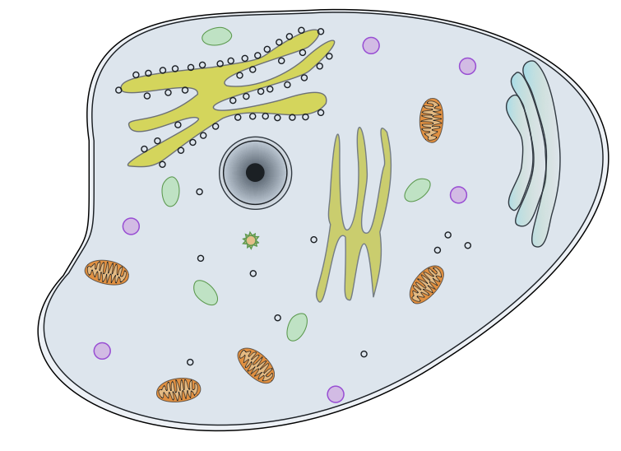

**Read pages 85-86**

*Choose the best answer: *The questions from pg. 87 are below. Write the complete answer to the question below.*

1. The mitochondrion of the cell_________________________________________
2. Which of the following statements is true of ribosomes?_______________________________________________________
3. Structures that support and give shape to plant cells are____________________
4. The storage of hereditary information in a eukaryotic cell is in the_____________

37 – 40. Develop an analogy of comparing your school to the cell. Use all the cell parts and compare them to locations within your school.

|  |  |
| --- | --- |
| **Name** | **School person/location** |
| **Cell Wall (plant cells only)** |  |
| **Plastids (plant cell only)** |  |
| **Vacuoles** |  |
| **Cell Membrane** |  |
| **Golgi Apparatus (Golgi Body)** |  |
| **Mitochondria** |  |
| **Microfilaments & Microtubles** |  |
| **Endoplasmic Reticulum (ER)** |  |
| **Nucleolus** |  |
| **Nucleus** |  |
| **Ribosomes** |  |
| **Lysosomes** |  |
| **Cytoplasm** |  |
| **Cytoskeleton** |  |

Cell Transport pg. 88

41. What two biochemicals make up most of the cell’s membrane? _______________ and _____________.

42. What is the purpose of cell membrane proteins?

43. What does it mean for a membrane to be “selectively permeable?”

44. Distinguish between Osmosis and Diffusion:

**Read pages 88-91 as a group using the reading strategy we learned.**

*45. Fill in the chart below*

|  |  |
| --- | --- |
| **Solution Type** | **Effect on cell** |
| **Isotonic** |  |
| **Hypotonic** |  |
| **Hypertonic** |  |

*Choose the best answer: *The questions from pg. 92 are below. Write the complete answer to the question below.*

1. The movement of substances into and out of a cell without the use of energy is called? _________________________________________
2. The movement of water across a semi-permeable membrane from an area of high water concentration to an area of low water concentration is called_____________________________________
3. A type of membrane which allows only certain molecules to pass through is called__________________________________________
4. A cell placed in a solution shrinks by the process of osmosis. What kind of solution is outside the cell?____________________________
5. If the solution surrounding a cell has a lower concentration of solutes than inside the cell, water will move into the cell through osmosis, causing it to expand. What kind of solution is surrounding the cell? _______________

Answer the following questions:

1. 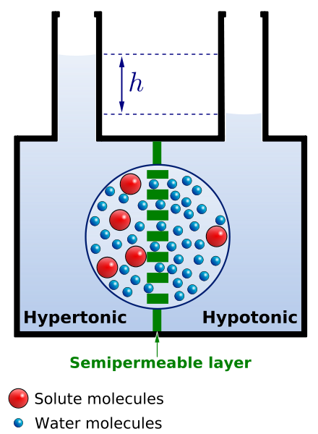How does active transport differ from diffusion?
2. Dried beans are soaked overnight in preparation for cooking. Explain the process affecting the beans. What will happen to the dried beans?
3. Water moves from hypotonic to hypertonic solutions. Use the picture below to explain this fact.

***Cell Transport True or False.***

1. ____ The cell membrane helps to maintain homeostasis.
2. ____ If you sprinkle salt on a slug, it will be harmed by the loss of too much water.
3. ____ The type of transport needed to move a molecule across the cell membrane is determined by the type of molecule and the concentration within the cell.
4. ____ Water tends to diffuse from a region where the solute is less concentrated to a region where the solute is highly concentrated.
5. ____ Endocytosis is the process of taking materials into the cell by means of in-folding of the cell membrane.

**Cell Energy**1. Complete the table below to compare the processes of Cellular Respiration and Photosynthesis: <http://cms.gavirtualschool.org/Shared/Science/Biology17/CellsAndCellTransport/index.html>

|  |  |  |
| --- | --- | --- |
|  | **Cell Respiration** | **Photosynthesis** |
| Organelle used: |  |  |
| When does this process occur? Choices:   * All the time * When light is present |  |  |
| Input Molecules?  Choices:   * Carbon dioxide and water * Glucose and oxygen |  |  |
| Output Molecules?  Choices:   * Carbon dioxide and water * Glucose and oxygen |  |  |
| Energy Source?  Choices:   * Chemical Bonds * Light |  |  |
| Anabolic or catabolic? |  |  |

2. Using the course textbook, could you label the diagram below and explain it? This is good practice to show what you know about this module and how the two processes are connected.

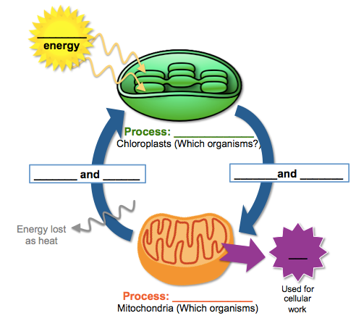

3. How are photosynthesis and cellular respiration opposite in terms of carbon dioxide?

4. How are photosynthesis and cellular respiration opposite in terms of oxygen?

***Examine each of the following equations that we studied in this module. Answer each question about the equations with a word or phrase***



1. This equation summarizes what **process**?
2. Is this process **aerobic** or **anaerobic**?
3. In what **organelle** does this process occur?
4. What are the **reactants (in words)?** What are the **products (in words)?**



1. This equation summarizes what **process**?
2. In what **organelle** does this process occur?
3. 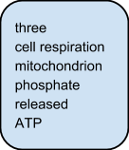What are the **reactants (use words)?** What are the **products (use words)?**

***Complete the following paragraph about energy flow in organisms using the word bank.***

27. In cells, most of the energy needed involves a molecule called _______________. It can be represented as A-P-P-P, where A stands for adenosine and the -P-P-P represents ___________ bonded _____________groups. When the bond between two phosphate groups is broken, energy is _______________ to do cell work. The process of ___________________ generates this high energy molecule from glucose within the organelle called the _________________.

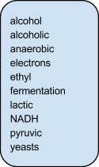***Complete the following paragraph about fermentation using the word bank.***

28. During the process of ________________ cells convert ________________ to NAD+ by passing high-energy ________________ back to ________________ acid. Because this process does not require oxygen, it is said to be ________________. There are two main types of this process: ________________ and ________________ acid. In this process, ________________ and a few other microorganisms form an ________________ called ________________ alcohol.

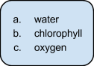***Photosynthesis Matching.***

29. ____ A necessary part of photosynthesis, this substance is found in chloroplasts and absorbs light.

30. ____ Waste product of photosynthesis that all organisms need for cellular respiration.

31. ____ Photolysis is the splitting of this molecule to replace an electron lost when light hits chlorophyll.