7th GRADE SOCIAL STUDIES

SYLLABUS AND CLASS PROCEDURES
2017/2018 MS. SHUFFIELD rshuffield@paulding.k12.ga.us ROOM 612

SOUTHWEST ASIA (MIDDLE EAST), AFRICA, SOUTHEAST ASIA (MONSOON ASIA)

Description

Throughout the year we will discuss the following topics for Southwest Asia (Middle East), Africa, and Southern and Eastern Asia:

  - Geographic Understandings
  - Government/Civics Understandings
  - Economic Understandings
  - Historical Understandings
Expectations
- Be on time, in your seat, and ready for class. This means you have your pencil sharpened and you are in your seat ready for class when the bell rings. After four tardies, you will be sent to the office.
- Be on task and do not disrupt others in the class. Take class notes or work on an activity or assignment as directed.
- Respect others and their property.
- Come prepared. This means bring all necessary materials to class.
- Refer to any discussions/activities we may have done as a class regarding rules and expectations.
- Refer to the student handbook. The rules in the student handbook apply in any school setting – including my classroom!
Course Materials
- Writing utensils (pens or pencils)
- Agenda
- Colored pencils or crayons
- Handheld pencil sharpener
- Loose-leaf paper
- Highlighter
- 3-Ring binder
- Composition notebook
- Dividers for binder (4 dividers labeled Warm-ups, Middle East, Africa, SE Asia

Homework
Students are responsible for documenting daily homework assignments and requirements in an agenda. These assignments will be posted daily on whiteboard. Students and parents can check Canvas to see class announcements, due dates for assignments, and dates for upcoming assessments.
Homework may be any of the following:
  - Reading and/or questions from the online textbook
  - Handouts
  - Other writing assignments
  - Research and projects
Late work
Late work is graded based on the following:
• Late nightly homework (such as textbook questions or handouts) will be accepted one day late with a 50% grade reduction.
• Larger assignments (such as written assignments or projects) will be accepted late with a 20% grade reduction the first day it is late, and a 10% grade reduction each additional day it is late. After three days, it will no longer be accepted.
Absent Work Policy
1. Homework due the day you are absent needs to be turned in on the day you return. It will be considered late if it is not turned in the day you return.
2. Homework assigned the day you are absent will have one day for every day you are absent to be turned in. For example, if you were absent for two days, you have two days from the day you return to make up your missing work.
3. Absences due to band/chorus trips or any other school activity still count as absences! You are still responsible for the work you miss in the same way you would be responsible for the work if you were absent from school. It is your responsibility to retrieve your missing work. I will not continuously ask you for your absent work – you need to take responsibility! Absent work will be located in the hanging folder for your class period. There will be an absent sheet with your name on it attached to the work that you missed with details on what the assignments are and when to complete them. It is up to you to pick up the missing work from that folder on the day you return.
Grades
Students will be given a variety of opportunities to demonstrate their mastery of the content. These opportunities will include classwork, daily assignments, projects, quizzes, assessments, performance tasks, etc. The following is a breakdown of each grading category:
- Summative Grades - 60% (assessments, projects, performance tasks)
- Formative Grades - 40% (classwork, quizzes, daily assignments)
Parents and students can log on to Parent Portal (Infinite Campus) to check grades and monitor student progress. Further directions on how to log on can be found on the “Ways You Can Stay Informed” handout.

Homework
Students are responsible for documenting daily homework assignments and requirements in an agenda. These assignments will be posted in the classroom. Students and parents can check Canvas to see class announcements, due dates for assignments, and dates for upcoming assessments.
Curriculum Map for 2017/2018
Unit Focus | Length of Unit | Standards | Concepts
Systems of Government and Economies Review  SS Concepts/Enduring Understandings | 2 weeks | SS7CG1a-c  SS7CG4a-c  SS7CG6a-c  SS7E1a-c  SS7E5a-c  SS7E8a-c | Location  Conflict and Change  Government  Human-Environment Interaction  Movement  Production, Distribution, and Consumption  Change and Continuity
Southwest Asia (Middle East)  - Geography  - Human Environment Interactions  - Religion/Culture/Ethnic Groups | 4 weeks | SS7G5a-b  SS7G6a  SS7G7a-b  SS7G8a-e | Location:  • Physical features  • Political features  • Population distribution  Human, Environment  Interaction:  • Environmental issues  Culture:  • Religions and ethnic groups  • Split of Islam  • Literacy rates and standard of living
Southwest Asia (Middle East) History | 4 weeks | SS7H2a-d | Conflict and Change:  • Collapse of Ottoman Empire and European partitioning  • Creation of Israel  Time, Change, & Continuity:  • Land, religion, and continuing conflict  • US presence in the Middle East
Southwest Asia (Middle East) Economics and Government | 3-4 weeks | SS7CG4a-c  SS7CG5a  SS7E5a-c  SS7E6a-d  SS7E7a-d | Governance:  • Forms of government  • Compare and contrast governments of Israel, Saudi Arabia, and Iran  Production, Distribution, & Consumption:  • Economic systems  • Compare and contrast economies of Israel, Saudi Arabia, and Turkey  • Voluntary trade E6abd  • Factors affecting economic growth in Saudi Arabia, Israel, and Iran  • Economic impact of oil
Africa Geography, HEI, Religion/Ethnic Groups | 4 weeks  (finish before Holiday Break) | SS7G1a-b  SS7G2a-c  SS7G3a  SS7G4a-c | Location:  • Physical features  • Political features  • Population distribution  Human, Environment  Interaction:  • Water pollution and unequal distribution of water  • Deforestation  • Desertification  Culture:  • Religions and ethnic groups  • Literacy rates and standard of living
Africa History | 3-4 weeks | SS7H1a-d | Time, Change, & Continuity:  • European partitioning  Conflict and Change:  • Nationalism in South Africa, Kenya, and Nigeria  • Apartheid  • Pan African Movement
Africa Economics and Government | 3 weeks | SS7CG1a-c  SS7CG2a-b *Republic of Sudan  SS7CG3a-b  SS7E1a-c  SS7E2a-b  SS7E3a-d | Governance:  • Forms of government  • Compare and contrast governments of Kenya and South Africa  • Independence for South Sudan  • Factors affecting access to education in Kenya and Sudan  • Government stability, AIDS, and famine  Production, Distribution, &  Consumption:  • Economic systems  • Voluntary trade  • Factors affecting economic growth in Nigeria and South Africa  • Natural resources and economic growth in all of Africa
Southern and Eastern Asia Geography, HEI, Religions/Culture | 4 weeks | SS7G9a-b  SS7G10a-b  SS7G11a-b  SS7G12a-c | Location:  • Physical features  • Political features G9b  • Population distribution  Human, Environment  Interaction:  • Water pollution in Yangtze and Ganges  • Air pollution and flooding in India and China  Culture:  • Religions  • Literacy rates and standard of living
Southern and Eastern Asia History | 4 weeks | SS7H3a-e | Conflict and Change:  • Nationalism and independence in India and Vietnam  • Rebuilding of Japan post- WWII  • Communism in China  • Foreign involvement in Korea and Vietnam
Southern and Eastern Asia Government and Economics | 2-3 weeks | SS7CG6a-c  SS7CG7a  SS7E8a-c  SS7E9a-c  SS7E10a-d | Governance:  • Forms of government  • Compare and contrast governments of India, China, and Japan  Production, Distribution, &  Consumption:  • Economic systems  • Compare and contrast economies of China, Japan, India, and North Korea  • Voluntary trade  • Factors affecting economic growth in India, China, and Japan
Financial Future | 1 week | SS7E4 | Production, Distribution, &  Consumption  • Personal money management in terms of income, spending, credit, saving, and investing
**This syllabus is a guide and is subject to change to accommodate class and individual needs.
**Please refer to the contact information page for the many different ways you can stay informed and communicate with me.
Dear Parent(s) and /or Guardian(s):
I have gone through these rules with your child in my class during the first week. My goal is to make sure that you are also aware of these policies. It would also be beneficial to go through these with your child as well. Also, I am asking that you fill out, sign, and return the bottom portion of this page. If you have any questions, please do not hesitate to contact me. I am available before and after school, as well as during 1st and 2nd period (8:50-10:25). I will get back to you as soon as possible!
Thank you for your time and support,
Ms. Shuffield
7th Grade Social Studies
Herschel Jones Middle School
rshuffield@paulding.k12.ga.us
(770) 443-8024

I have reviewed the materials in the syllabus, including expectations, homework policy, absent policy, and all other details.
Parent / Guardian Signature: ______________________________________Date:____________________
Student Signature: ______________________________________________ Date:____________________
Parent / Guardian Contact Information: Name of Parent(s) and / or Guardian(s): _________________________________________________________________________________
Child resides with: _________________________________________________________________
Method of preferred communication: _____________________________________
Best time for telephone contact: _________________________________________
Phone #: _________________________________ Alternate Phone #__________________________
Email Address (Please print clearly): ____________________________________________________
Do you have internet access at home? Y / N (Circle One)
Is there anything you would like to share about your child that you think would help me best understand your child’s educational needs? (i.e. allergies, medical, home life, academic or social concerns)
______________________________________________________________________________________________________________________________________________________________________________________________________________________________________________________________________________________________________
WAYS YOU CAN STAY INFORMED TEAM 702

EMAIL
SOCIAL STUDIES- MS. SHUFFIELD: rshuffield@paulding.k12.ga.us
MATH- MRS. HAHN: chahn@paulding.k12.ga.us
SCIENCE- MRS. BOTTS: jbotts@paulding.k12.ga.us
ELA- MRS. POPE: kpope@paulding.k12.ga.us

PARENT PORTAL
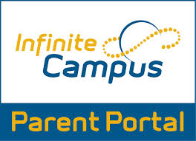
http://www.paulding.k12.ga.us/domain/4142
The purpose of Infinite Campus Parent Portal is to provide parents/guardians and students with instant access to their student’s current grades, assignments, missing work, and attendance.

Parent Portal Information and Support
Parent Portal Usage Policy (PDF)
Parent Portal Login
Getting Your District ID - Parent Portal App

For questions or issues with Parent Portal, please email portal@paulding.k12.ga.us

CANVAS

https://paulding.instructure.com/
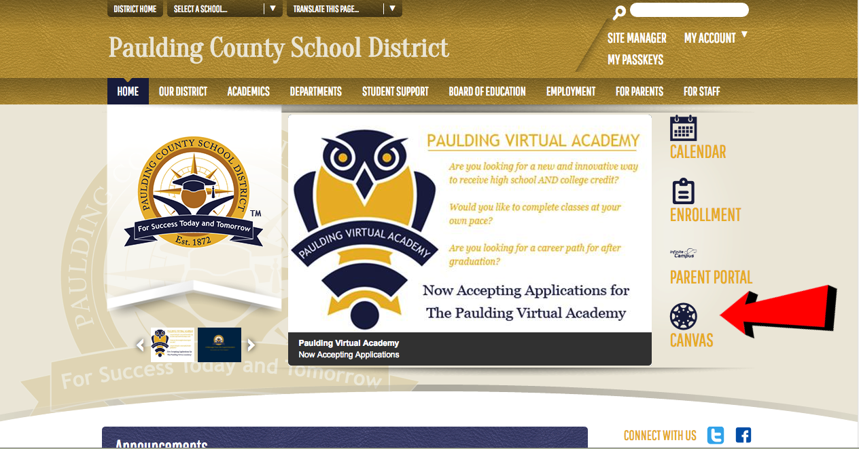

Click “Click Here For an Account” text and create an account for you and your student.

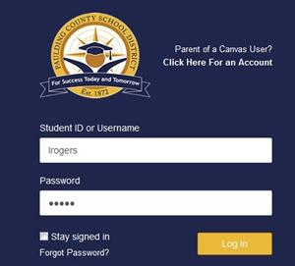

REMIND
https://www.remind.com/
The purpose of Remind is to communicate with parents/guardians and students through text-messages regarding important reminders.
The process for joining this class is shown below.

Class Codes:
Mrs. Pope ELA: @pope702
Mrs. Pope Advanced ELA: @pope702adv
Mrs. Hahn Math: @hahn702
Mrs. Hahn Accelerated math: @hahn702acc
Ms. Shuffield Social Studies:@shuff702
Ms. Shuffield Advanced Social Studies:@shuff702adv
Mrs. Botts Science: @botts702
Mrs. Botts Advanced Science: @bottsadv

